Customer Service Representative Incentive Report

Purpose
This report is used to evaluate the incentive of Customer Service Representatives. Their incentive is based on multiple pieces of information. (i.e. how many rental agreements opened, how much LDW sold, was there any upgrade of rate, length of rental, whether any optional coverage are sold, Fuel Purchase Option sold, what rate was used for rental, base walkup rate up sell).

Parameters
Name | Description
Vehicle Type | One or vehicle types.
Location | One or All BRAC rental locations. Rental locations can only request their location.  This is the location where the contract was opened.
RBR Date Range | From and to date (dates are inclusive). For Checked Out Contracts each date must be past or current date, for Checked In Contracts both dates must be in past. From date must be less than or equal to date. *
CSR Name | One or All CSRs

Report is available as scheduled.

Report Layout
- Totals:
- By CSR (see layout)
- By location (see layout).
- By company (see layout).
- Sequence by rate name and level.
- Use dividing lines where appropriate to make report easier to read.
- Columns:
Column heading | Display
Detail line 1
ID | Employee ID
Contract | Contract Counts
Rental Days | Number of Rental Days
Walk Up | Number of Walk Ups
FPO | Number of FPO sold
Additional Driver | Additional driver revenue contracts.
All Seats | Include Baby Seats, Infant Seats Revenue length.
ALL LDW | Total LDW Revenue
PAI  $ | Total PAI (personal accident insurance) charge (expected for contracts still checked out, actual otherwise). “-“ if none purchased.
PEC  $ | Total PEC (personal effects coverage) charge (expected for contracts still checked out, actual otherwise). “-“ if none purchased.
Upgd  $ | Total upgrade charge (expected for contracts still checked out, actual otherwise). If no upgrade charge (i.e. is zero) field will be blank. Upgrade can be requested at open or check out. The CSR who opened the contract is credited with the upgrade.
Walkup Up sell | Walkup Base Rate Up sell
Reservation Up sell | Contract Revenue – Reservation Revenue

Business Notes

- All of the amounts printed in this report will be net of all taxes (both additional taxes and included taxes are not included in the amounts shown in the report).
- All contract charges amount are inclusive of adjustments.
- Foreign Vehicle Rental is not included in the calculation

Technical Notes
- The following shows the source of the data for selected columns (unless specified the source applies for both open and checked in contracts):
Column | Source
Walk Up | Number of Walk up Contracts opened by the CSR
FPO | Number of FPOs sold by the CSR
Additional Driver | Total of Amount from all Contract Charge Item records with a charge type of Additional Driver
All Seats | Total of Amount from all Contract Charge Item records with a charge type of Baby Seats, Infant Seats, etc
All LDW | Total of Amount from all Contract Charge Item records with an Optional Extra ID which is an optional extra with type LDW
PAI  $ | Total of Amount from all Contract Charge Item records with an Optional Extra ID which is an optional extra with type PAI.
PEC  $ | Total of Amount from all Contract Charge Item records with an Optional Extra ID which is an optional extra with type PEC.
Ski Rack | Total of Amount from all Contract Charge Item records with a Charge Type of Ski Rack
Upgrade Charge | Total of Amount from all Contract Charge Item records with a Charge Type of Upgrade (20).
Walkup Up sell | Total Amount of Walkup Base Rate Up sell  See Following for the detail of Base Amount Calculation
Reservation Up sell | Total Amount of Reservation Up sell (Contract Revenue – Reservation Revenue)  Only If there are no upgrade charges and Contract Revenue is greater than Reservation revenue, we will have the reservation up sell.

CSR Incentive Walk Up Up-Sell Calculation Logic

1. Base Rate Amount Retrieval:

Gets the base rates information (Rates Name, Rate Level) from Location Vehicle Rates Listing Entered by the user using Location Maintenance Screen, based on the contract pick up location, pickup date and vehicle Class.? Get Base Rates dollar amount from vehicle rate related tables.

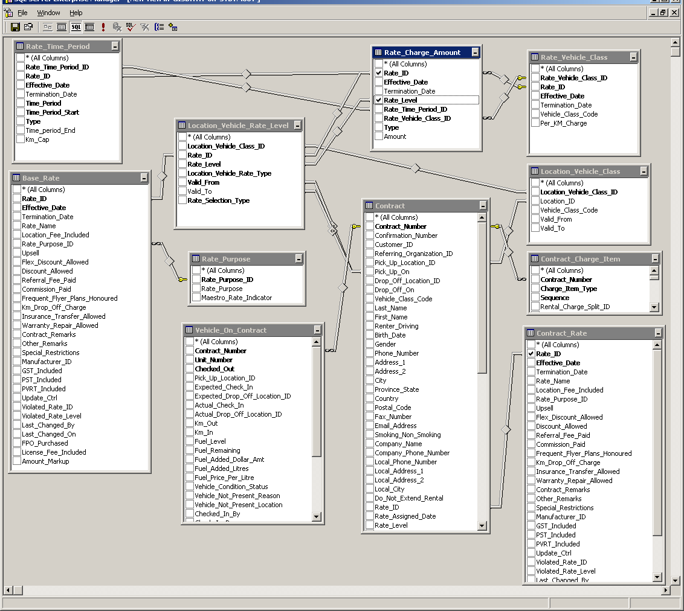

Detailed Step of Getting the Base Amount

- According to Contract’s Vehicle Class, Pick Up Location, Pickup Time, retrieving the related base rate name, level from Location_Vehicle_Rate_Level, through table Contract, Location_Vehicle_Class, Location_Vehicle_Rate_Level.
- Using Base Rate Name and Level to retrieve based amount through table Rate_Charge_Amount, Rate_Time_Period, Rate_Vehicle_Class.
- Get Length of Rental from Contract, Vehicle_On_Contract Tables, according to the last vehicle rented on the contract.
- Retrieve Contract Rates Information accounting contract’s Rate_ID and contract’s Rate_Level.
- Restriction: Only Get Base Rates and Contract Rates with rate purpose of “Standard”

2. Rental Length Calculation:

Formula:

Rental Hours will round up instead of round off.
Eg.1.1 Hours will equals to 2 hours

3 hours above will be considering as a day.

RentalDays1=RentHours/24.00
RemainingHours= RentHours-RentDays1*24

If RemainingHours >=3 Then
RentalDays=1
Else
RentalDays2=RemainingHours /3.0

TotalRentalDays=RentalDays1+RentalDays2

If TotalRentalDays<1 then
TotalRentalDays=1

3. Base Amount Calculation:

Base Amount for Weeks:
When WeeklyBaeRateAmount<>0 and Contract Rate is using Weekly Rates
Then BaseAmountWeek=WeeklyBaeRateAmount*(TotalRentalDays/7))

Base Amount for Days:
- When WeeklyBaeRateAmount<>0 and DailyBaseAmount<>0 and Contract Rate is using Both Daily and Weekly Time Period.
BaseAmountDay= (DailyBaseAmount* RemainDays)
- When WeeklyBaeRateAmount=0 or contract rate is only using daily rates, and DailyBaseAmount<>0
BaseAmountDay= DailyBaseAmount *TotalRentalDays
- When and DailyBaseAmount=0 or contract is only using weekly, and WeeklyBaeRateAmount<>0 BaseAmountDay= (WeeklyBaeRateAmount/5) * RemainDays

BaseAmount= BaseAmountWeek+ BaseAmountDay

Remarks:
1. Number of Hours always rounding up
2. Get Number of days from total number of rental hours, if there is extra hours,
Round Up First, after rounding up, if it is more than 3 hour, count them as a day, less than 3 hours, drop it.
3. Using Contract Rate Time Period (Day, Week) to determine if daily or weekly, or both daily and weekly rates should be used.

4. The Logic of Linking to Contract Rates

Contract |  |  |  | Base Amount
DailyBase | DailyPeriod | WeeklyBase | WeeklyPeriod |  |  | Case
1 | 1 | 1 | 1 | Both | A | Case 1
1 | 1 | 1 | 0 | Daily | B | Case 2
1 | 1 | 0 | 1 | Daily | B | Case 3
1 | 1 | 0 | 0 | Daily | B | Case 4
1 | 0 | 1 | 1 | Weekly | C1 | Case 5
1 | 0 | 1 | 0 | Both | A | Case 6
1 | 0 | 0 | 1 | Daily | B | Case 7
1 | 0 | 0 | 0 | Daily | B | Case 8
0 | 1 | 1 | 1 | Weekly | C1 | Case 9
0 | 1 | 1 | 0 | Weekly | C2 | Case 10
0 | 1 | 0 | 1 | None |  | Case 11
0 | 1 | 0 | 0 | None |  | Case 12
0 | 0 | 1 | 1 | Weekly | C1 | Case 13
0 | 0 | 1 | 0 | Weekly | C2 | Case 14
0 | 0 | 0 | 1 | None |  | Case 15
0 | 0 | 0 | 0 | None |  | Case 16
1= Exist
0= Not Exist
Total 16 Cases

Base Amount Calculation using the following Timer period:
A Both Daily and Weekly
B Daily Only
C1 Weekly (With Weekly Period)
C2 Weekly (Without Weekly Period)

Eg.
Case 1: When both Daily Base Amount and Weekly Amount exist, and both the daily period and weekly period Time Charges exist in Contract Time Charge, then use both daily and weekly base rate to do the base amount calculation.

Case 2: When both Daily Base Amount and Weekly Amount exist, but only the daily period Time Charges exist in Contract Time Charge, then use only daily base rate to do the base amount calculation.

Case 3: When Only Daily Base Amount exist, even both the daily period and weekly period Time Charges exist in Contract Time Charge, use only daily base rate to do the base amount calculation.

And so on…….

Remarks:

The calculation does not include Foreign Vehicle Rental
CSR Performance Report Includes Foreign Vehicle Rental

